MODULE 4 – INTRODUCTION TO DBMS

LAB EXERCISES

7. Data Manipulation Language – DML
Lab 1.
Insert three records into the courses table using the INSERT command.
Ans.
1. INSERT INTO courses(course_name, course_duration) VALUES ('computer science', '4 year'),
('Digital marketing', '3 year'), ('data science', '2 year');
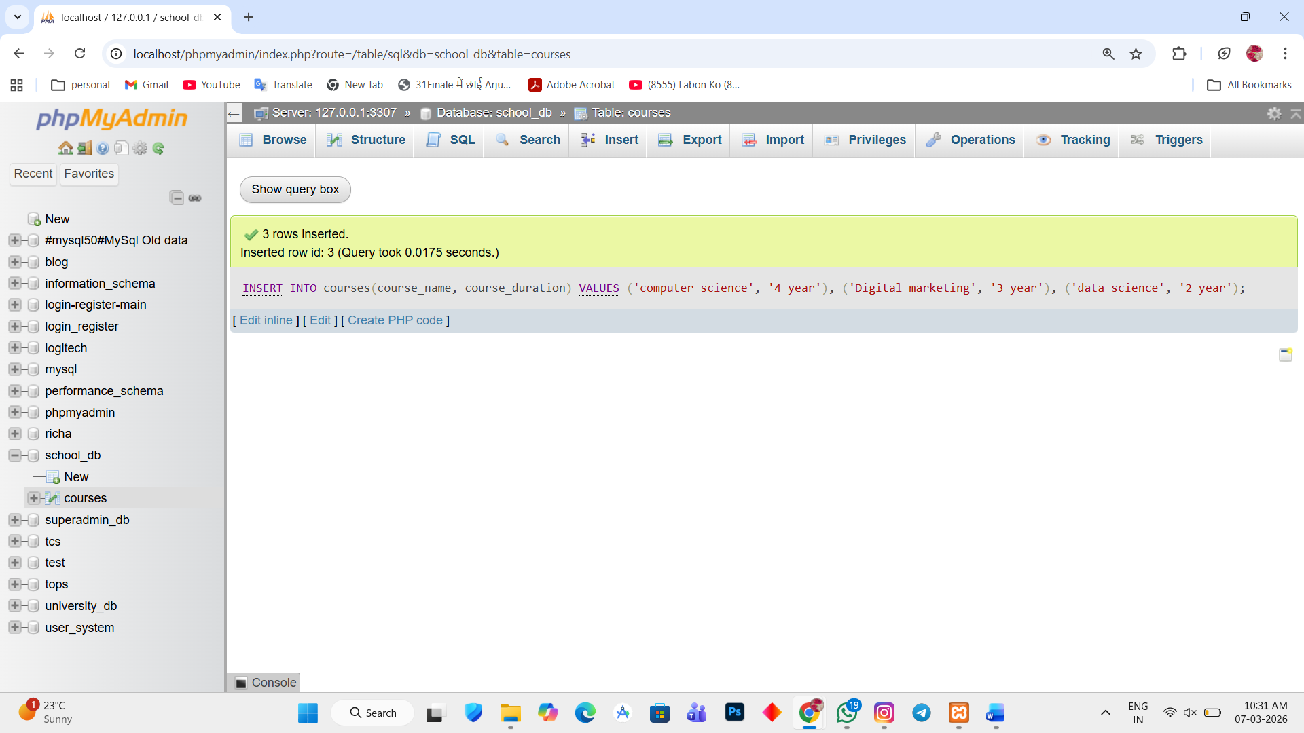

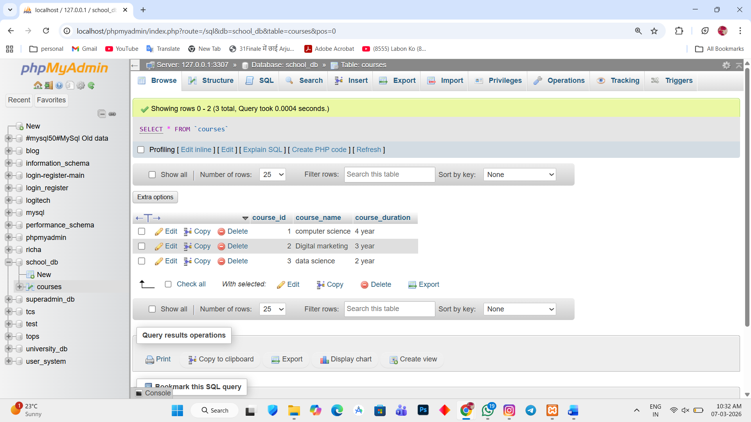

Lab 2.
Update the course duration of a specific course using the UPDATE command.
Ans.
1. UPDATE courses SET course_duration = '3 year' WHERE course_id = 3;
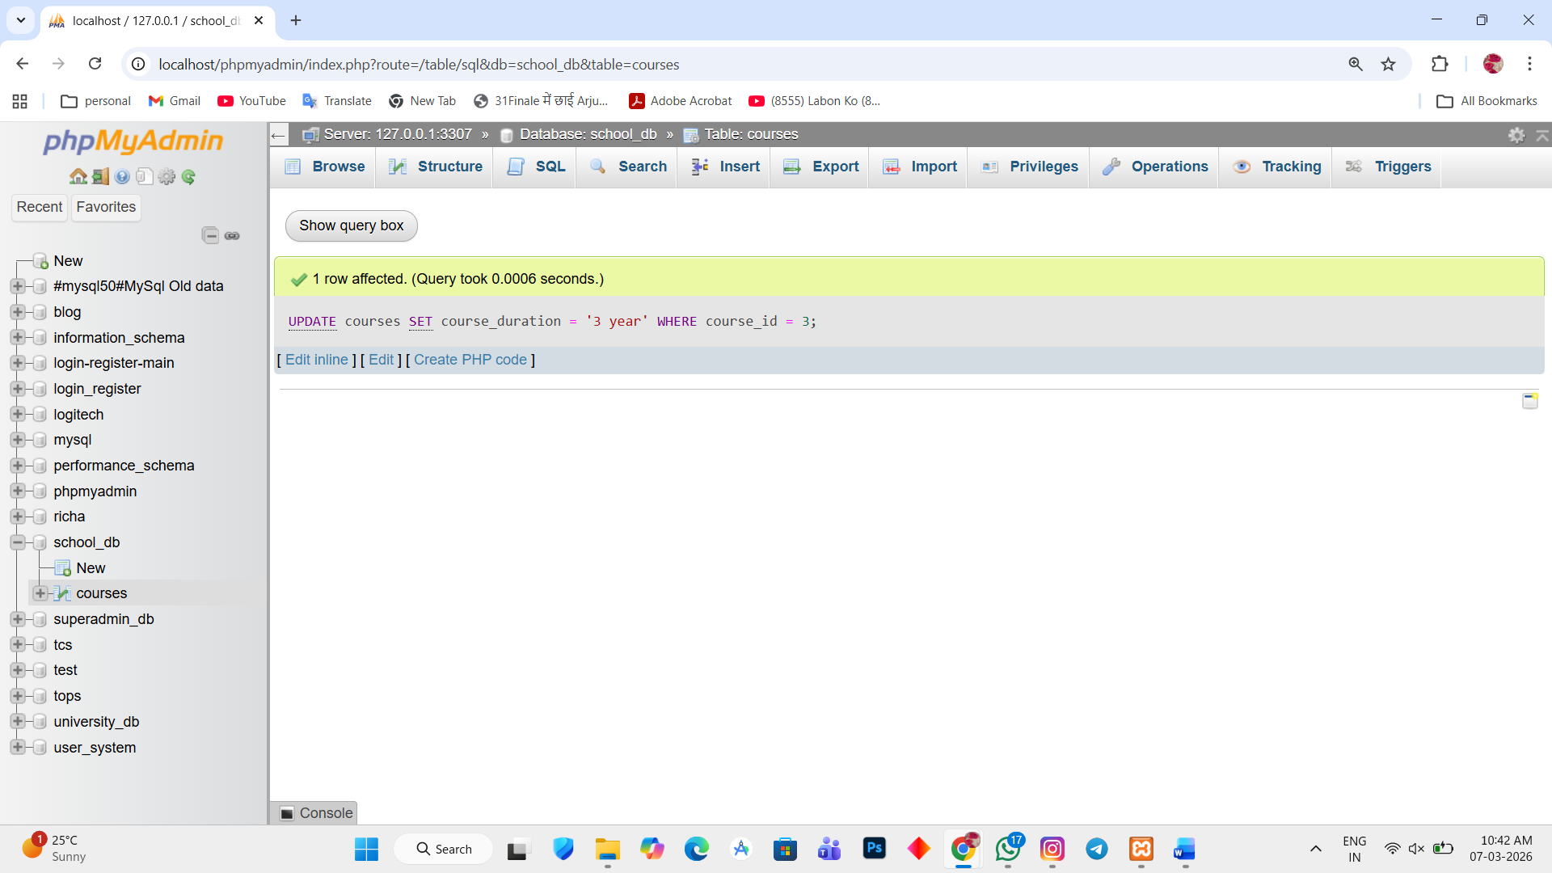

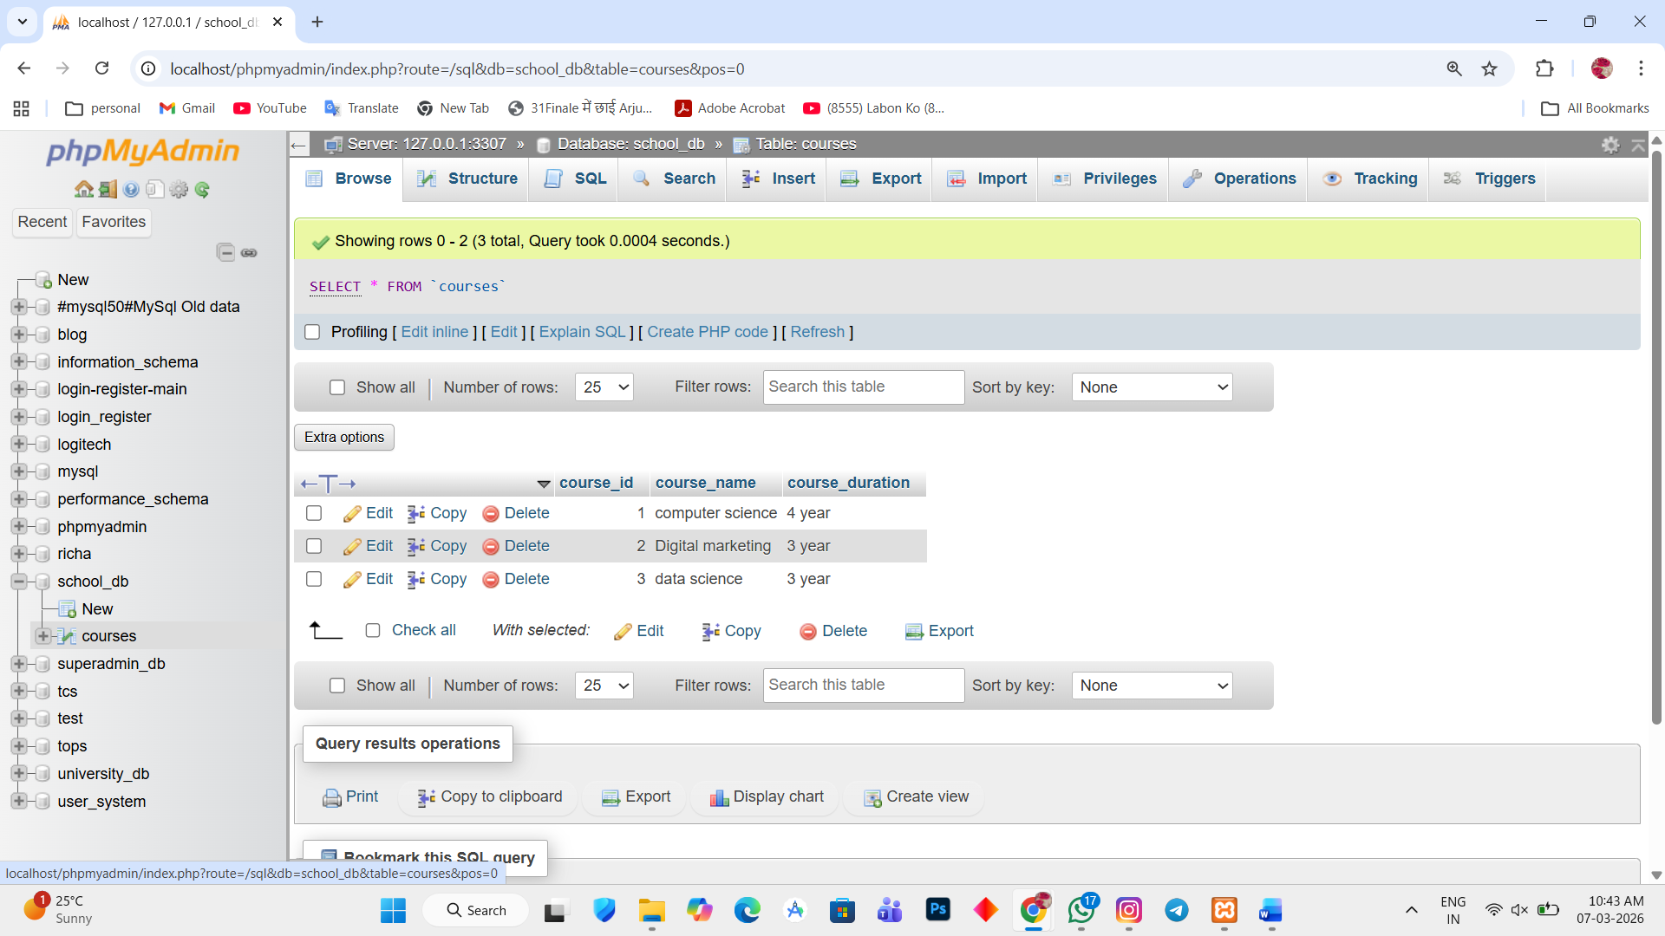

Lab 3.
Delete a course with a specific course_id from the courses table using the DELETE command.
Ans.
1. DELETE FROM courses WHERE course_id = 3;
